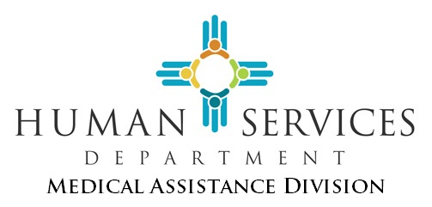

NEW MEXICO BRAIN INJURY SERVICES FUND (BISF) PROGRAM
HUMAN SERVICES DEPARTMENT
Medical Assistance Division

BISF FREEDOM OF CHOICE
&
RELEASE OF PROTECTED HEALTH INFORMATION (PHI)

This form lets BISF Program participants in the Metro region choose their Service Coordination Agency (SCA), and it helps with the transfer of their files. It should only be used by those who wish to change the SCA that helps them.

Section A: Fill in the date and your information below.

Date:

Name: |  | Social Security Number:
Address: |  | Date of Birth:
City, State, Zip Code: |  | Phone Number (w/ area code):
My Current Service Coordination Agency: County:

Section B: You have the right to choose the SCA that will help you in the region where you live. (See page 3 for map of regions.)

Check  One | Service  Region | BISF Service Coordination Agency  Authorized to Use or Disclose PHI | Address of Authorized Regional  BISF Service Coordination Agency
 | Metro | CNRAG (Care Network Resource Assistance Group) | 315 Central Ave, Suite M, Albuquerque, NM 87102
 | Metro | Los Amigos LLC | 1601 Randolph Court, Suite 110-S, ABQ, NM 87106

“I, the undersigned, hereby give the SCA that now helps me the right to give my files and PHI to the new SCA. (The old SCA is noted in Section A. The new SCA is noted in Section B.) My new SCA needs these, so I can get help from the BISF Program. The SCA can share it with the New Mexico Human Services Department (HSD) / Medical Assistance Division’s Brain Injury Services Fund (BISF) Program. I know HSD and all those involved in my care will need my PHI, This lets them give me the help and services I need.”

“I also allow my new SCA (Section B), to have, use and/or share my PHI as needed. The BISF Program’s Fiscal Intermediary Agent (FIA) needs my PHI. They will use it to get me my services. They will use it to pay for those services too. I know that the PHI that is shared has to do with my brain injury. It also has to do with the services I get through the BISF Program. The PHI helps them do their jobs. All shared PHI will stay private.”

“I know that I can look at the PHI that will be shared. I can also ask my SCA for a copy of this release any time. If I no longer want BISF services, I can take back this permission at an y time. To do so, I must tell the SCA in writing. This will not apply to what my BISF Service Providers have done or need to do to close my case. Also, it will not apply to what they must do to pay for services I have used.”

Name of Participant Name of Parent of Legal Guardian (if applicable)

Signature of Participant, Parent, or Legal Guardian Date

If signed by legal guardian, describe the legal authority that lets you act on behalf of the participant. Please show legal proof that you are the legal guardian or show that you hold power of attorney for health-care decisions.

If you need help filling out this form, please contact:
NM Brain Injury Resource Center
1504 4th Street NW
Albuquerque, NM 87102
1-844-366-2472

Send your signed form to:
The Brain Injury Services Fund Program
HSD/ Medical Assistance Division / ESPB / Brain Injury
PO Box 2348
Santa Fe, NM 87504-2348

If you have any other questions, contact the HSD Brain Injury Program Manager at:
505-827-7218

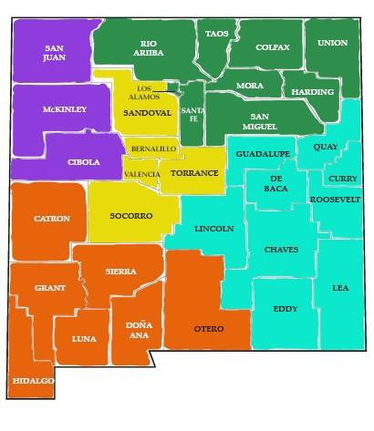
Brain Injury Service Fund Service Coordination Agencies by County and Region
RIO ARRIBA

METRO | Care Network Resource Assistance Group (CNRAG), Inc.  315 Central Ave. NW, Suite M, Albuquerque, NM 87102  PH: 505-936-5807 or 575-526-9084 | FAX: 888-838-7086
METRO | Los Amigos LLC  1601 Randolph Court, Suite 110-S, Albuquerque, NM 87109  PH: 505-204-6035 | FAX: 505-474-2804
NORTHEAST | Los Amigos LLC  1435 St. Francis Dr., Santa Fe, NM 87505  PH: 505-204-6035 | FAX: 505-474-2804
NORTHWEST | Care Network Resource Assistance Group (CNRAG), Inc.  315 Central Ave. NW, Suite M, Albuquerque, NM 87102  PH: 505-936-5807 or 575-526-9084 | FAX: 888-838-7086
SOUTHEAST | Care Network Resource Assistance Group (CNRAG), Inc.  225 E. Idaho, Las Cruces, NM 88005  PH: 505-936-5807 or 575-526-9084 | FAX: 888-838-7086
SOUTHWEST | Care Network Resource Assistance Group (CNRAG), Inc.  225 E. Idaho, Las Cruces, NM 88005  PH: 505-936-5807 or 575-526-9084 | FAX: 888-838-7086

NEW MEXICO BRAIN INJURY SERVICES FUND (BISF) PROGRAM
HUMAN SERVICES DEPARTMENT
Medical Assistance Division

BISF FREEDOM OF CHOICE
&
RELEASE OF PROTECTED HEALTH INFORMATION (PHI)

FORM INSTRUCTIONS

PURPOSE:
The MAD 790 form should be filled in by Brain Injury Services Fund (BISF) Program participants. It is for those who live in the Metro region. The form lets them choose their Metro region Service Coordination Agency (SCA). The SCAs available in the Metro region, beginning July 1, 2019, are listed on page 1 of the form. They are also shown on the map on page 3. This form is also for those who wish to change their SCA. The participant fills in, signs, and sends the form back to HSD. The form allows for the transfer of the participant’s files to the agency they choose. The form is available on the HSD website.

INSTRUCTIONS FOR THE PARTICIPANT:
Section A (page 1):
- The participant fills in the date, their name, address, phone number and the name of their current SCA.

Section B (pages 1 and 2):
- The participant checks the name of the SCA they want to help them. They can refer to the map on page 3. This page lists addresses and phone numbers of the agencies that are available in their region.
- Information is given about how the participant’s Protected Health Information (PHI) will be shared and kept private.
- On page 2, the participant or guardian prints their name. They must also sign and date the form.
- The participant or guardian sends the form to the HSD address on page 2 below the signature.

Those who need help in filling in the form may call the NM Brain Injury Resource Center. That is listed on page 2 of the form below the signature.

ROUTING:
The participant sends the signed and completed form to HSD/MAD. HSD keeps the original. HSD sends a copy of the form to the SCAs as needed. HSD directs the current SCA to send the participant’s files to the new SCA. The SCAs will help with the participant’s transition of services, as needed.

FORM RETENTION:
Permanent

Flesch-Kincaid grade level: 5.2

